Evolutionary-Patterns- Recognition-Tools
1.0
User Manual

Table of Contents
Software operation 2
1. Environment configuration 2
2.Running the Main Pipeline 2
2.1 Command-line Arguments 2
2.1.1 Required Arguments 2
2.1.2 Optional Arguments 3
2.1.3 Advanced Parameters 3
2.2 Examples 3
2.2.1 Single Tree Example 3
2.2.2 Multiple Trees Example 3
Description of the workflow 4
1. Topology Encoder 4
1.1 Input 4
1.2 Output 4
1.3 Steps 5
1.4 Notes 5
1.5 Example Command 6
2.Motif Binary Encoding 6
2.1 Input 6
2.2 Output 6
2.3 Steps 7
2.4 Notes 8
2.5 Example Command 8
3.Merge Topology and Motif Data 8
3.1 Input 8
3.2 Output 9
3.3 Steps 9
3.4 Notes 10
3.5 Example Command 10
4. Evolutionary pattern recognition 10
4.1 Input 10
4.2 Output 11
4.3 Steps 12
4.4 Notes 13
4.5 Example Command 13
5. Evolutionary Pattern Visualization 13
5.1 Input 13
5.2 Output 14
5.3 Steps 17
5.4 Notes 18
5.5 Example Command 18

Software operation

1. Environment configuration
Before running the main process, it is necessary to install the dependent software and configure the environment.
Execute the following script for automatic installation and configuration：

bash ./step0-SoftwareInstall-main.sh

This script will：
- install the necessary Python packages,
- set up the R environment,
- create a local virtual environment (.venv).

2.Running the Main Pipeline
The main pipeline is executed using the script Evolutionary_patterns_recognition.sh. To run the pipeline with example data use:

bash ./Evolutionary_patterns_recognition.sh -i tree.nwk -n NAME -m motif.xml

2.1 Command-line Arguments
The pipeline accepts both required and optional parameters.

2.1.1 Required Arguments
Option | Description
-i, --input | One or more phylogenetic tree files in Newick format (.nwk). Multiple files can be provided separated by spaces.
-m, --motif | Motif definition file in XML format (e.g., output from MEME).

2.1.2 Optional Arguments
Option | Description | Default
-n, --names | List of gene names corresponding to the input tree files. If not provided, names are inferred from filenames. | (inferred from filenames)
-o, --output | Output directory where results will be stored. | ./output
-r, --reference | Reference sequence or annotation file for optional annotation in downstream analyses. | None
--format | Output format for merged results. Options: multi, tab, or detailed. | multi
--validate | Validate the motif file before processing to ensure correct format. | False
--verbose | Print detailed progress information and log messages. | False

2.1.3 Advanced Parameters
Option | Description | Default
-zh, --z-high | Upper Z-score threshold used in evolutionary pattern recognition. | 3.0
-zl, --z-low | Lower Z-score threshold used in evolutionary pattern recognition. | -2.0
-ht, --hgt-threshold | Threshold for detecting horizontal gene transfer events. | 5.0
-cs, --converge-similarity | Convergent similarity threshold for identifying similar motifs across genes. | 0.7
-ct, --converge-topology | Convergent topology score threshold used in tree pattern analysis. | 3.0

2.2 Examples

2.2.1 Single Tree Example
bash ./Evolutionary_patterns_recognition.sh -i treeA.nwk -m motifs.xml -n A
This command runs the pipeline for a single gene tree and motif file. The output will be stored in the default ./output directory.

2.2.2 Multiple Trees Example
bash ./Evolutionary_patterns_recognition.sh \
-i treeA.nwk treeB.nwk \
-n A B \
-m motifs.xml \
-o results/ \
--validate \
--verbose
This command runs the pipeline for two genes, validates the motif file, prints detailed logs, and stores results in the results/ directory.

Description of the workflow

Topology Encoder
The Topology Encoder module generates a unique binary code for each leaf node in a phylogenetic tree, based on the tree's topology. This encoding provides a standardized representation of the tree structure, which is essential for downstream evolutionary pattern analyses.

1.1 Input
Input data:
One or more phylogenetic trees in Newick format (.nwk).
Command-line parameters:
Parameter | Description
-i / --input | Path(s) to one or more Newick tree files.
-n / --names | Optional names corresponding to each tree. If not provided, inferred from filenames.
-o / --output | Output directory path. Default: ./output.

1.2 Output
Output file 1: NAME_topology_codes.txt

File contents:
Each input tree produces a per-tree topology code output file containing:
- Species/leaf node name
- Assigned topology code

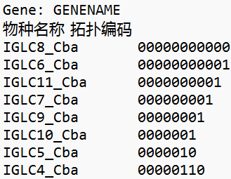
Figure 1. example NAME_topology_codes.txt

Output file 2: topology_codes_summary.txt

File contents:
Aggregated summary file - combines results from all processed trees. Each tree section is separated by =====.

1.3 Steps
1. Tree Parsing
- Load the Newick file and construct a tree object (ete3.Tree).
- Branch lengths are ignored; only topology is used.

- Topology Code Assignment
- Traverse each tree recursively from the root.
- Leaf nodes receive binary strings representing their path.

- Output Generation
- Generate per-tree output files and a combined summary file.

- Batch Processing
- Supports multiple input trees.
- Tree names can be specified manually or inferred automatically.

- Error Handling
- Invalid Newick files trigger warnings and are skipped.
- Non-binary nodes generate warnings but do not stop execution.

1.4 Notes
- Binary codes represent the path from the tree root to each leaf node.
- Non-binary nodes are handled by assigning incremental numeric codes (0, 1, 2, …) to children in order.
- For binary nodes: left child = 0, right child = 1.

1.5 Example Command
python step1-topology-encoder.py -i example.nwk -n NAME -o ./output

2.Motif Binary Encoding
The Motif Binary Encoding module parses motif information from a MEME XML output file and generates binary presence/absence codes for each gene. Each binary string represents whether specific motifs are present (1) or absent (0), enabling comparative motif analyses across genes.

2.1 Input
Input data:
One MEME XML file containing motif prediction results.
Command-line parameters:
Parameter | Description
-i / --input | Path to the MEME XML file containing motif predictions.
-o / --output | Output file path (e.g., motif_binary_encoding.txt).
--validate | Optional XML validation before processing.
--verbose | Optional detailed logging of motif parsing and encoding.

2.2 Output
Output file: motif_binary_encoding.txt

File contents:
1.Gene motif binary encoding
Each row corresponds to a gene and contains:
- Gene name
- Binary motif code string (1 = present, 0 = absent)
- Number of motifs present
- List of motifs present
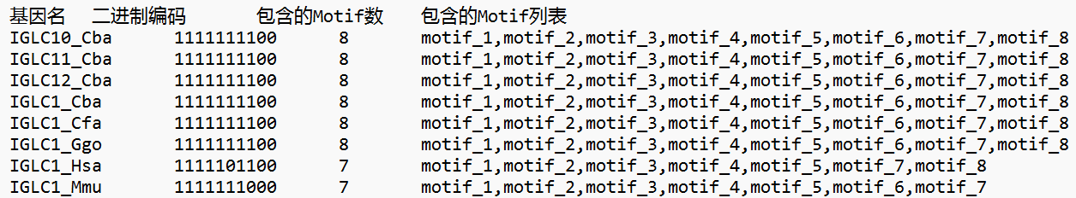
Figure 2. example of gene motif binary encoding
2.Header and motif metadata
- Total number of motifs and genes
- Mapping of motif positions in the binary code (position → motif ID, name, width, number of sites, E-value)
- Notes on encoding
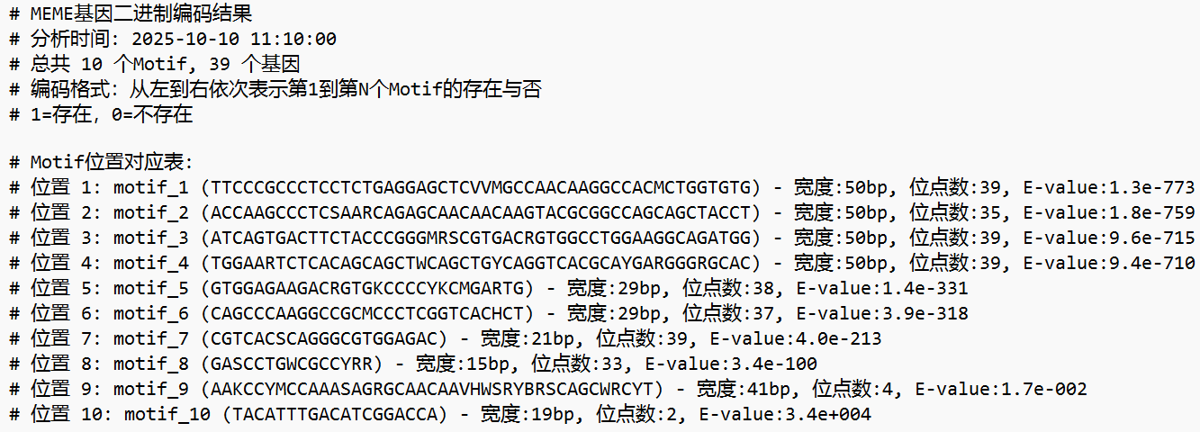
Figure 3. example of header and motif metadata

2.3 Steps
- XML parsing
- Extract genes, motifs, and relationships from the input XML file.
- Build a dictionary linking each gene to its associated motifs.

- Binary Encoding Generation
- For each gene, generate a binary code string sorted by motif ID.
- “1” indicates motif presence; “0” indicates absence.

- Output Writing
- Write results to the main output file with header and per-gene data.

- Verbose Summary (Optional)
- Prints explanatory information to the console

- Validation (Optional)
- Verify XML structure consistency and completeness before encoding.

2.4 Notes
- Binary codes are consistent across all genes, reflecting the same motif order.
- Motifs with no occurrences in any gene will still occupy a position in the binary string (value = 0).

2.5 Example Command
python step2-meme-encoder.py -i example.xml -o motif_binary_encoding.txt --verbose --validate

3.Merge Topology and Motif Data
The Merge Topology and Motif Data module combines the topology codes (from Step 1 Topology Encoder) with the motif binary encodings (from Step 2 Motif Binary Encoding). The resulting dataset links each leaf node (species or gene sequence) with its motif pattern, supporting downstream comparative and evolutionary analyses.

3.1 Input
Input data:

1.Topology file — TREE_NAME_topology_codes.txt or topology_codes_summary.txt, generated by the Topology Encoder.
Contains per-tree topology codes for each leaf node.

2.Motif file — motif_binary_encoding.txt, generated by the Motif Binary Encoding module.
Contains per-gene binary motif codes.

Command-line parameters:
Parameter | Description
-t / --topology | Topology codes file path.
-m / --motif | Motif binary encoding file path.
-r / --reference | Optional reference format file.
-o / --output | Output file path.
--format | Output format (multi, tab, detailed). Default: multi.
--verbose / -v | Display detailed processing information.

3.2 Output
Output file: merged_result.txt
Contents:
1.Per-tree merged section
Each block represents a tree and contains lines for its leaf nodes with their corresponding topology and motif codes.

2.Formats:
- Multi:
SpeciesName<TAB>TopologyCode MotifCode
- Tab:
SpeciesName<TAB>TopologyCode<TAB>MotifCode
- Detailed:
SpeciesName<TAB>TopologyCode<TAB>MotifCode<TAB>TopologyLength<TAB>MotifLength
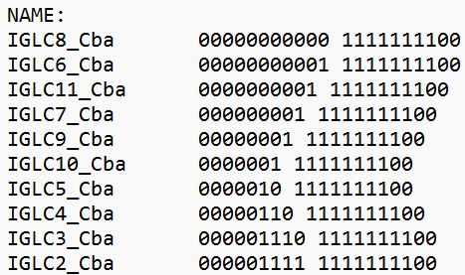
Figure 4. example of merged topology and motif codes file

3.3 Steps
1. Topology File Parsing
- Build a dictionary {tree → leaf_nodes → topology_code} from topology files.

- Motif File Parsing
- Build a dictionary {gene → motif_code} from motif binary encoding file.

- Data Merging
- Match leaf nodes (species or gene sequences) with corresponding motif codes.
- Missing motif entries are filled with “N/A”.

- Output Writing
- Export merged data in selected format (multi, tab, or detailed).

- Verbose Summary (Optional)
- Displays detailed progress information during execution

3.4 Notes
- Topology and motif data are linked by gene names or leaf node identifiers; ensure consistent naming between Step 1 and Step 2 outputs.
- Supports merging multiple trees in batch mode.
- Missing or unmatched genes are reported but do not interrupt execution.
- The output file can be directly used for downstream analyses.

3.5 Example Command
python step3-merge-topology-motif.py \
-t topology_codes_summary.txt \
-m motif_binary_encoding.txt \
-o merged_result.txt \
--format tab \
--verbose

Evolutionary pattern recognition
The Evolutionary Pattern Recognition module detects evolutionary signals such as clustering, accelerated evolution, horizontal gene transfer (HGT), and convergent evolution.
It analyzes the merged per-gene dataset generated in Step 3 Merge Topology and Motif Data.

4.1 Input
Input data:
One text data file (merged_result.txt) produced by the Merge Topology and Motif Data module.
Each line contains species name and combined topology–motif code in one of the supported formats (multi, tab, or detailed).
Command-line parameters:
Parameter | Description
-i / --input | Path to merged input file (default: ./merged_result.txt).
-m / --min_cluster_size | Minimum cluster size(s) to detect. Accepts one or more integers (e.g. 2 3).
-zh / --z_threshold_high | Upper Z-score threshold (default: 3.0) for accelerated evolution or outlier detection.
-zl / --z_threshold_low | Lower Z-score threshold (default: –2.0) for evolutionary stagnation detection.
-ht / --hgt_threshold | Threshold for horizontal gene transfer detection (default: 5.0).
-cs / --converge_similarity | Similarity threshold for convergent evolution detection (default: 0.7).
-ct / --converge_topology | Minimum topology distance for convergence detection (default: 3.0).

4.2 Output
Output file: evolutionary_summary.txt

File contents:
1.Cluster information
- Cluster prefix (shared topology/motif path)
- Species list per cluster
- Cluster size
- Mean and standard deviation of pairwise weighted Hamming distances
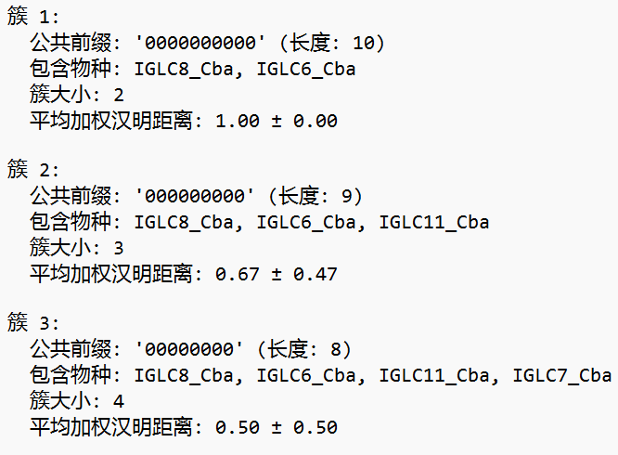
Figure 5. example of cluster information
2.Detected anomalies
- Species with high Z-score (> Z_HIGH): potential special or accelerated evolution events
- Species with low Z-score (< Z_LOW): possible evolutionary stagnation
- Advanced pattern reports
3.Horizontal Gene Transfer (HGT) candidates
- Accelerated Evolution species
- Convergent Evolution pairs (remote species with high feature similarity but large topology distance)
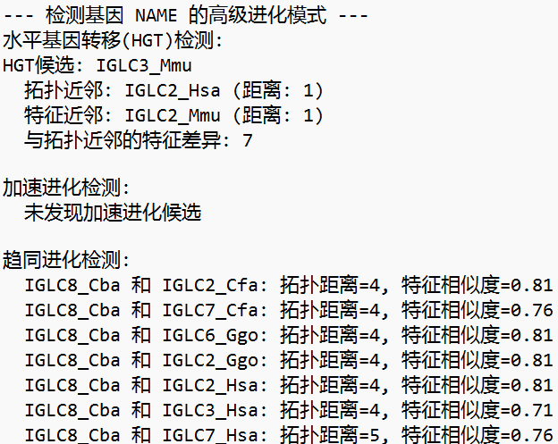
Figure 6. example of HGT candidates

4.3 Steps
1. Input Parsing
- Read the merged dataset and separate per-gene, per-species encodings.
- Handle both space- and tab-delimited formats automatically.

- Normalization
- Equalize all encoding lengths using “X” padding placeholders.
- Ensure alignment for weighted Hamming distance computation.

- Cluster Detection
- Build prefix trees from normalized codes.
- Detect clusters of species sharing common encoding prefixes.
- Minimum cluster size is controlled by --min_cluster_size.

- Statistical Analysis
- Compute mean and standard deviation of pairwise Hamming distances.
- Detect outlier species using Z-scores:
– Z > Z_HIGH: accelerated or unusual evolution
– Z < Z_LOW: stagnation or conservation

- Advanced Evolutionary Event Detection
- HGT Detection: find species with mismatched topology–feature proximity.
- Accelerated Evolution: flag species with code length ≥ 1.5× average.
- Convergent Evolution: detect distant species with high motif similarity (> --converge_similarity).

- Summary Reporting
- Output per-gene and global statistics.
- Summarize cluster metrics, anomaly counts, and advanced event candidates.

4.4 Notes
- Uses weighted Hamming distance, accounting for both binary and numeric motif codes.
- Multiple cluster size thresholds can be tested in a single run (e.g. -m 2 3).
- Input data must come directly from Step 3 (merged_result.txt), with consistent naming across species and genes.
- Advanced pattern detection thresholds (Z, HGT, Convergence) can be tuned for specific datasets.
- Missing or malformed entries are skipped without interrupting the analysis.

4.5 Example Command
python step4-summary.py \
-i ./output/merged_result.txt \
-m 2 3 \
-zh 3.0 -zl -2.0 \
-ht 5.0 \
-cs 0.7 \
-ct 3.0 \
> ./output/evolutionary_summary.txt

Evolutionary Pattern Visualization
The Evolutionary Pattern Visualization module generates graphical summaries of evolutionary patterns detected in Step 4 Evolutionary Pattern Recognition. It visualizes clustering, convergence, and horizontal gene transfer (HGT) using dendrograms, scatter plots, and network diagrams.

5.1 Input
Input data:
One text data file (evolutionary_summary.txt) produced by the Step 4 Evolutionary pattern recognition module.
Command-line parameter:
Parameter | Description
<output_dir> | Path to the directory containing per-gene results (e.g., output/NAME).

5.2 Output
Output file 1: cluster_analysis.png
File contents:
Scatter plot of cluster size vs. average Hamming distance (colored by shared prefix length).
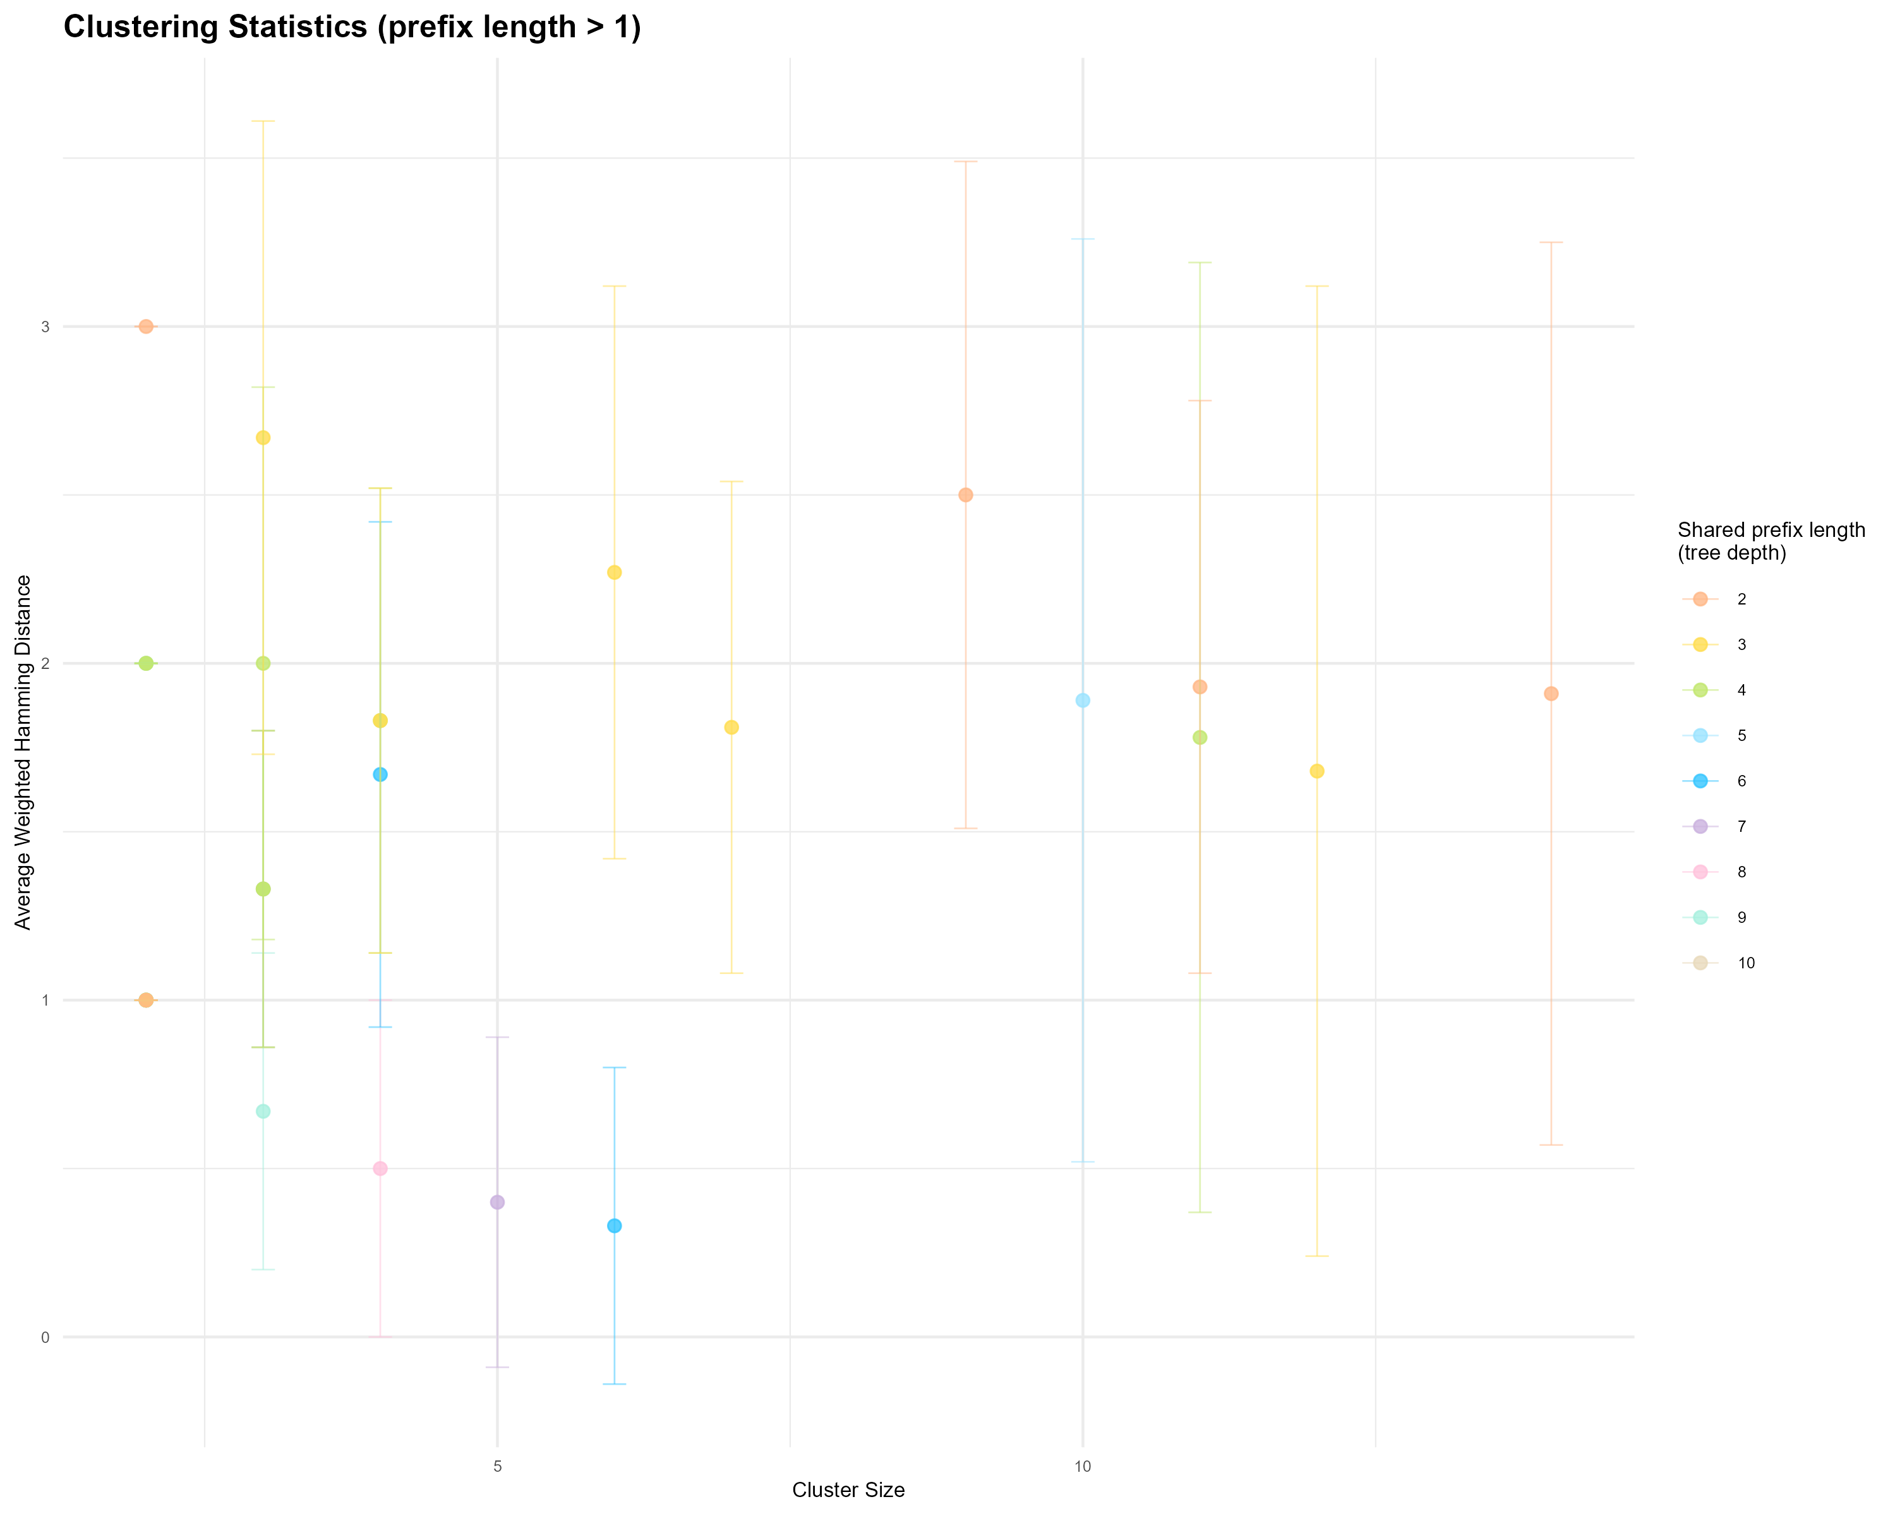
Figure 7. example of clusters visualization
Output file 2: dendrogram.png
File contents:
Hierarchical clustering dendrogram based on shared prefixes.
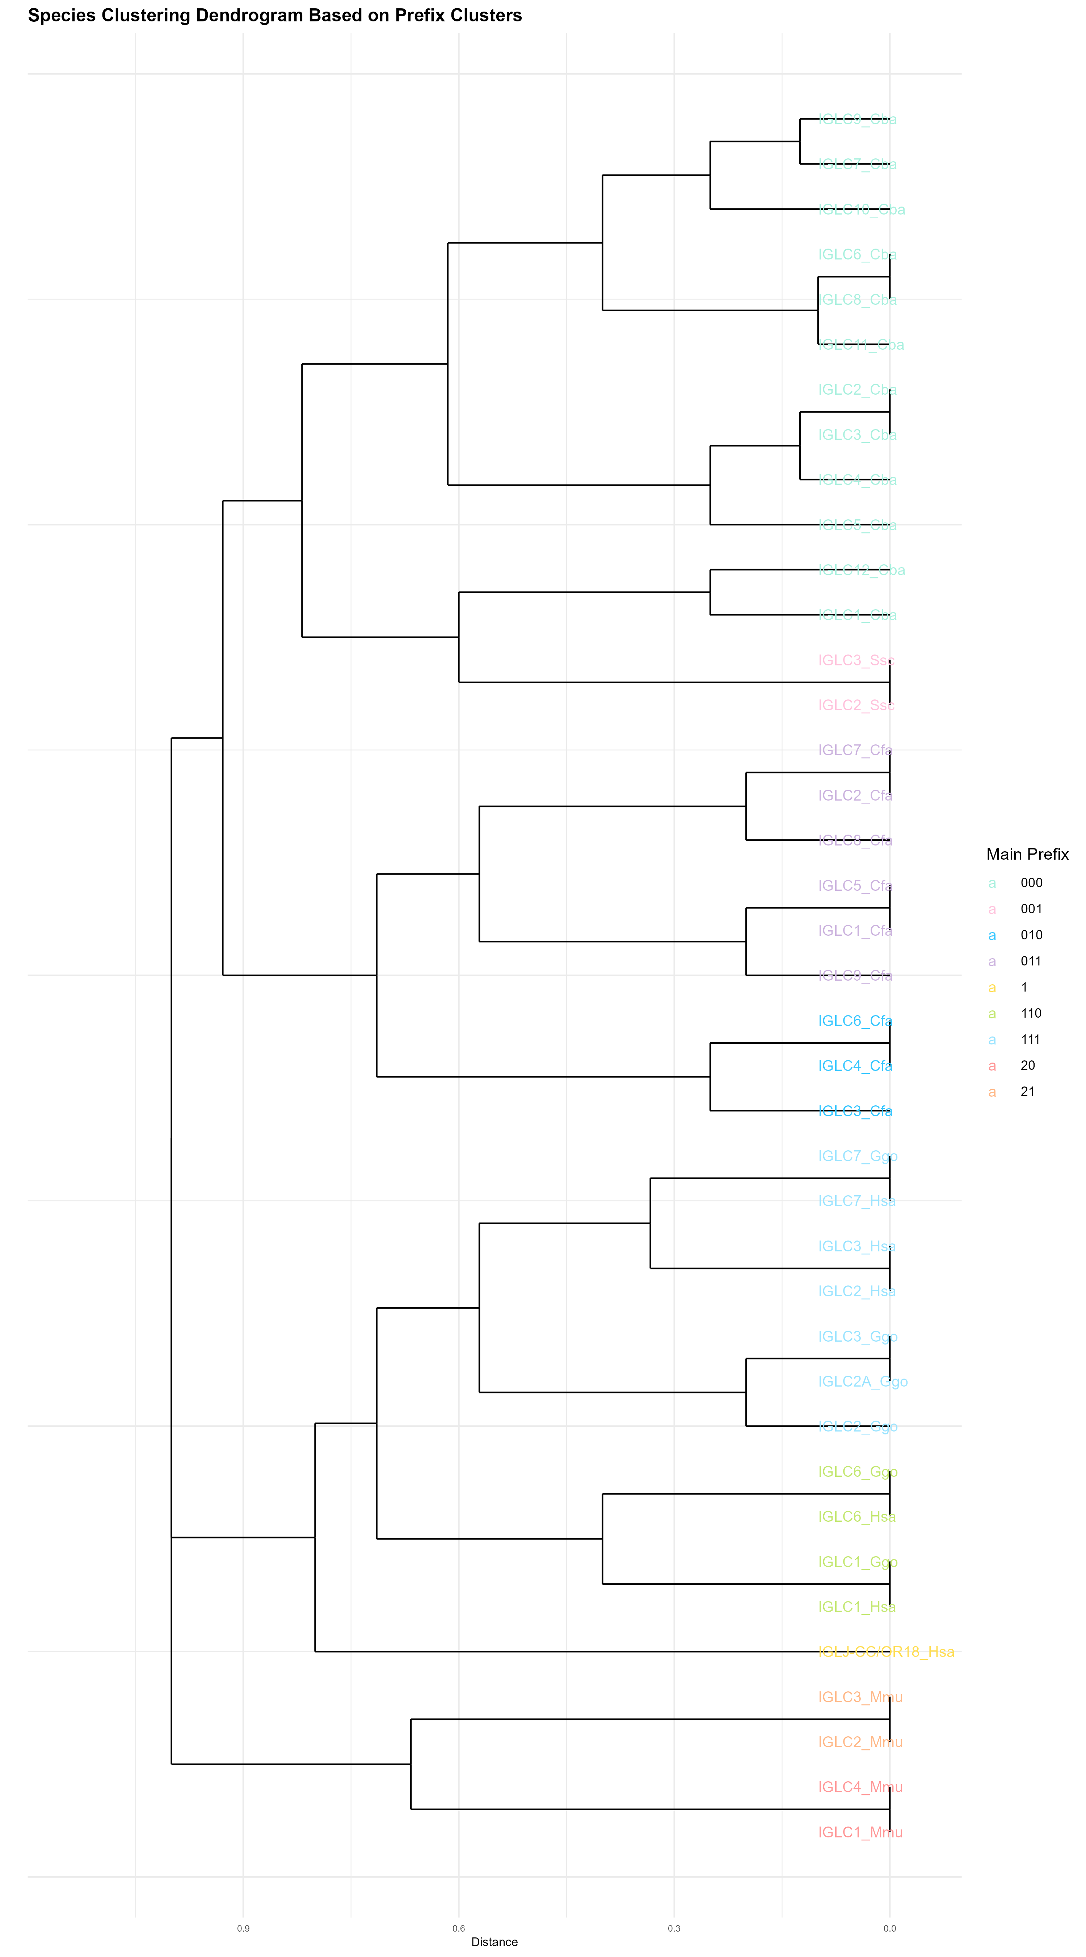
Figure 8. example of a clustering dendrogram

Output file 3: convergence_analysis.png
File contents:
Scatter plot showing feature similarity vs. topological distance for convergent evolution pairs.
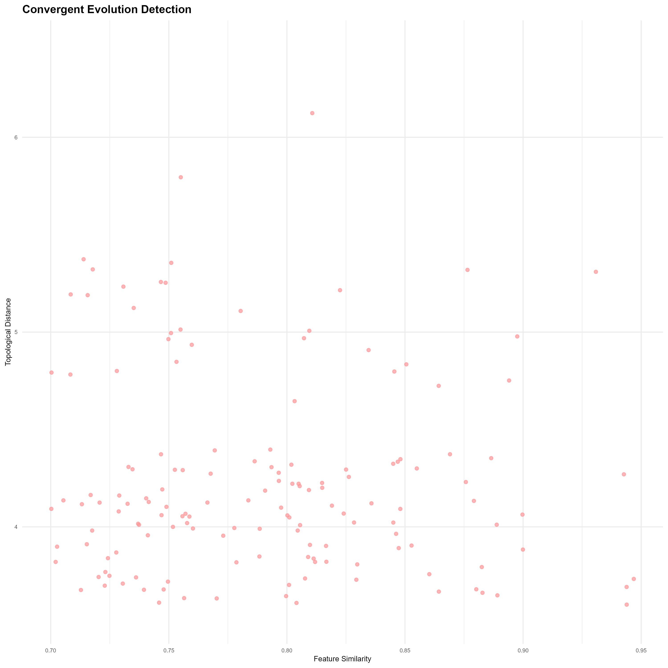
Figure 9. example of a convergence visualization
Output file 4: hgt_network.png
File contents:
Network diagram illustrating candidate HGT relationships between species.
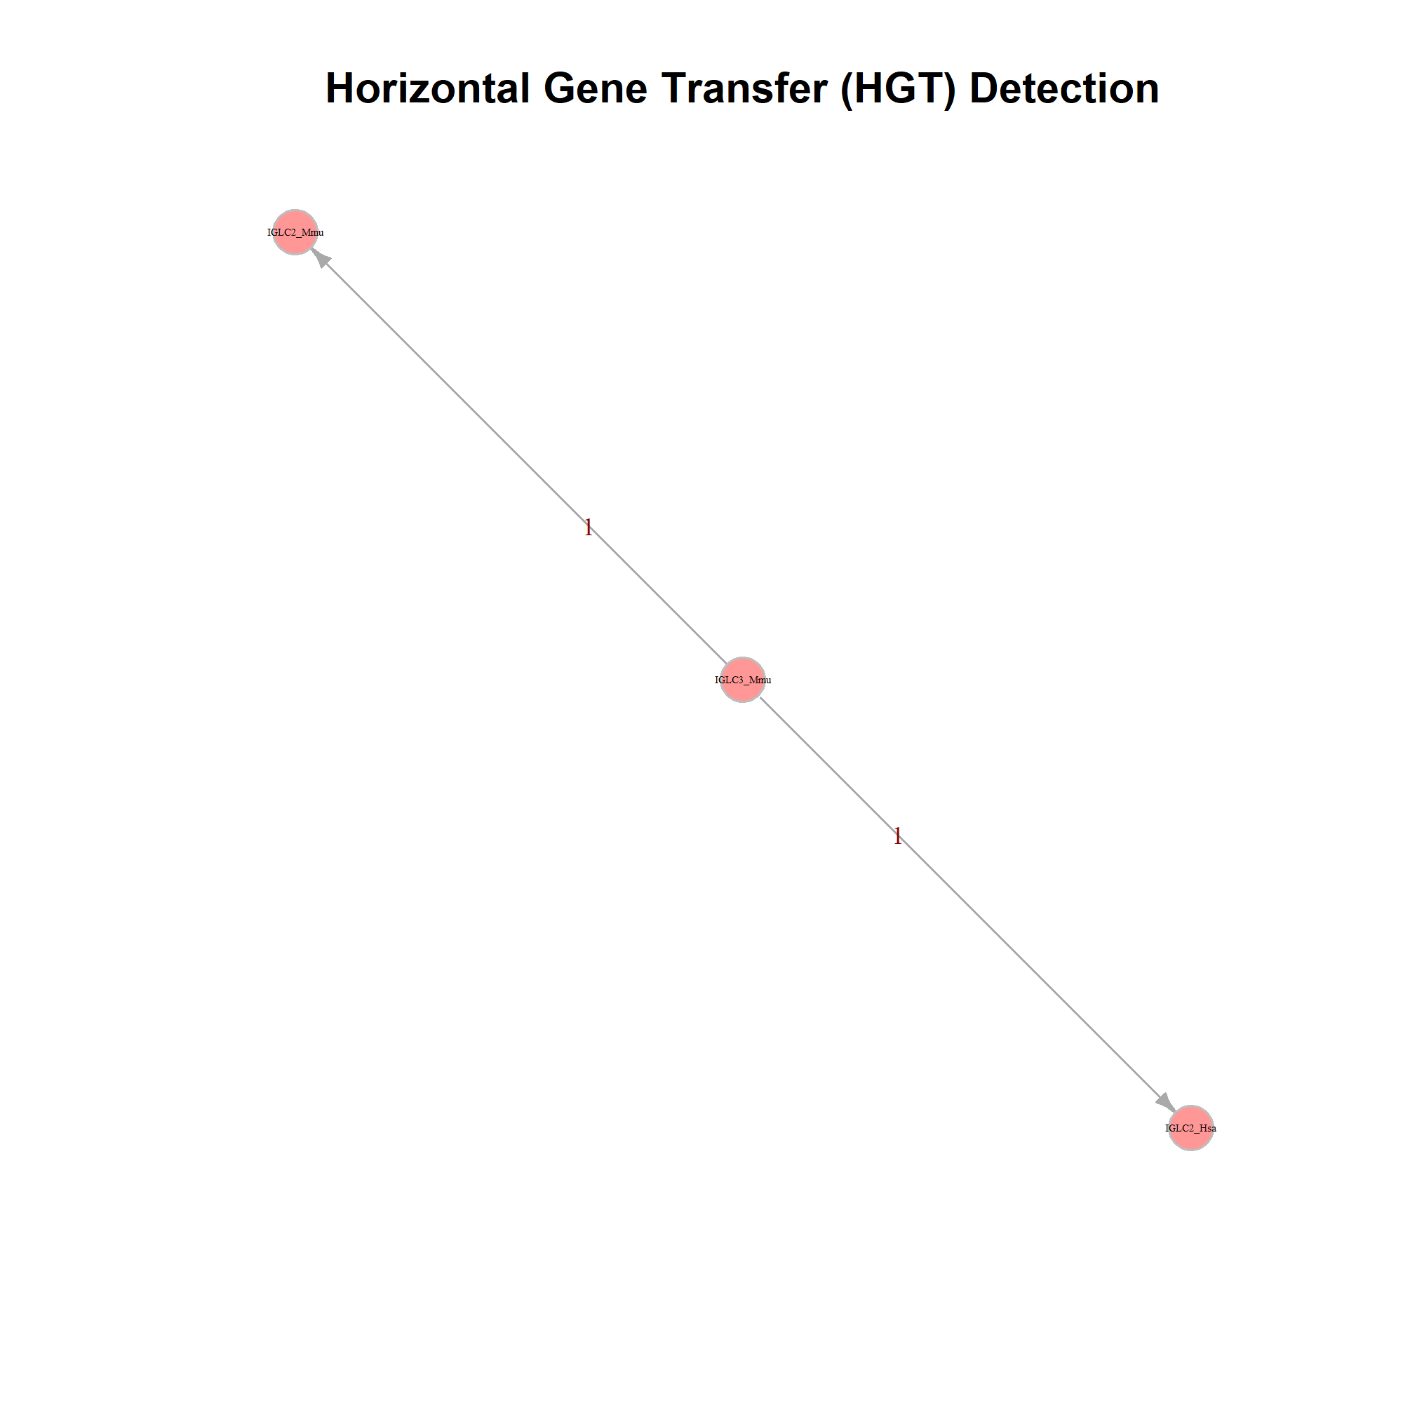
Figure 10. example of a HGT relationships network
Output file 5: cluster_data.csv
File contents:
Table with cluster summary statistics.
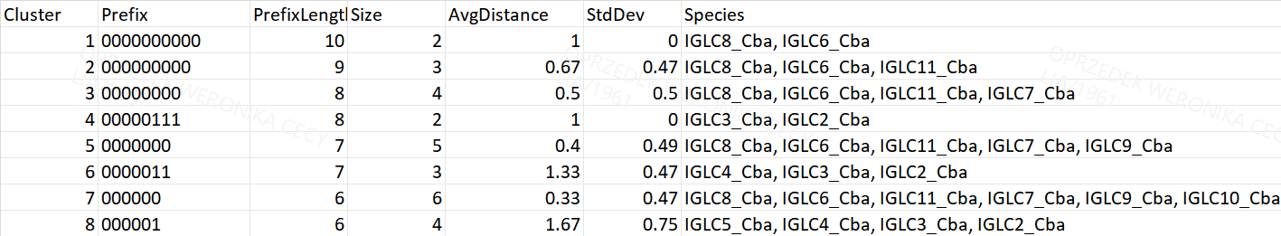
Figure 11. example of a cluster summary statistics table
Output file 6: hgt_data.csv
File contents:
Table with HGT candidate information.

Figure 12. example of a HGT candidate information

Output file 7: convergence_data.csv
File contents:
Table with convergent evolution pairs.
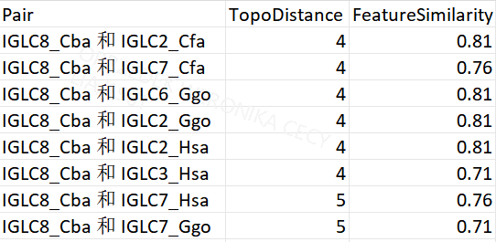
Figure 13. example of a convergent evolution pairs table

5.3 Steps
1. Initialization and Argument Parsing
- Read output directory path and verify presence of _summary.txt.

- Cluster Data Extraction
- Parse cluster sections (“簇 N”) from the summary file.
- Extract shared prefix, prefix length, species list, cluster size, and statistics.
- Save results as cluster_data.csv.

- HGT Data Extraction
- Parse “HGT候选” entries and neighbor relationships.
- Compute topological and feature distances.
- Export to hgt_data.csv and prepare network data.

- Convergent Evolution Data Extraction
- Identify species pairs with reported feature similarity and topology distance.
- Save results to convergence_data.csv.

- Cluster Scatter Plot Generation
- Plot cluster size vs. mean weighted Hamming distance.
- Use error bars for standard deviation and color points by prefix length.

- Dendrogram Construction
- Convert species–prefix matrix into a binary distance matrix.
- Perform hierarchical clustering (hclust).
- Visualize species relationships via shared prefix structure.

- Convergent Evolution Plot
- Plot feature similarity vs. topological distance for all species pairs identified in convergence analysis.
- Each point represents a detected convergent pair.

- HGT Network Visualization
- Build network (igraph) linking candidate species and neighbors.
- Edges represent either feature or topological proximity.
- Export visualization to hgt_network.png.

- Result Export
- Save all plots as high-resolution PNGs.
- Write all tables as CSV files to the specified output directory.

5.4 Notes
- Visualization is automatically triggered for each tree during the main pipeline loop.
- If Rscript is unavailable, the visualization step is skipped safely without interrupting the workflow.
- The gtb_palette color scheme ensures consistent styling across all plots.
- Cluster and distance plots automatically adjust their scale to dataset size.

5.5 Example Command
Rscript step5-visualization.R output/NAME

